Quick mongodb different queries
🧠 Decision rule (remember this)
Question wording | Use
how many times sold | $sum: "$items.quantity"
how many orders | $sum: 1
unique customers | $addToSet + $size
If the question says unique / distinct / different / no duplicates → use $addToSet inside $group.
Examples of trigger words:
- unique customers
- distinct products
- different categories
- customers who bought both
- count of distinct users
👉 Brain should auto-think: $addToSet

✅ $addToSet
- Removes duplicates
- Counts entities
uniqueProducts: { $addToSet: "$items.product" }
Use when:
- “unique customers”
- “distinct products”
- “how many different categories”

🔥 Common interview trap
Q: “Total number of customers per product”
- If unique customers → $addToSet + $size
- If total purchases → $sum: 1
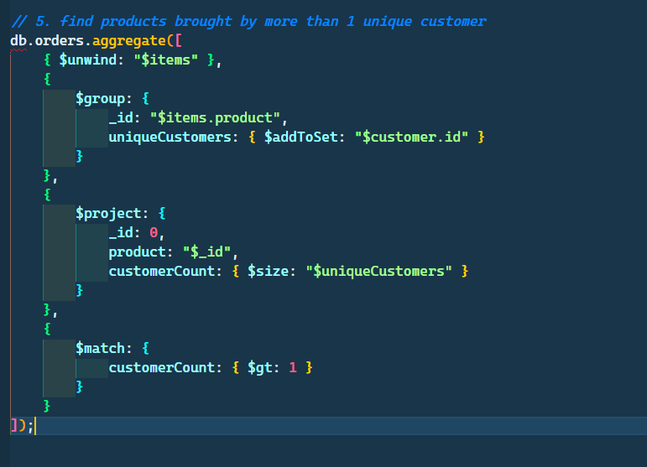
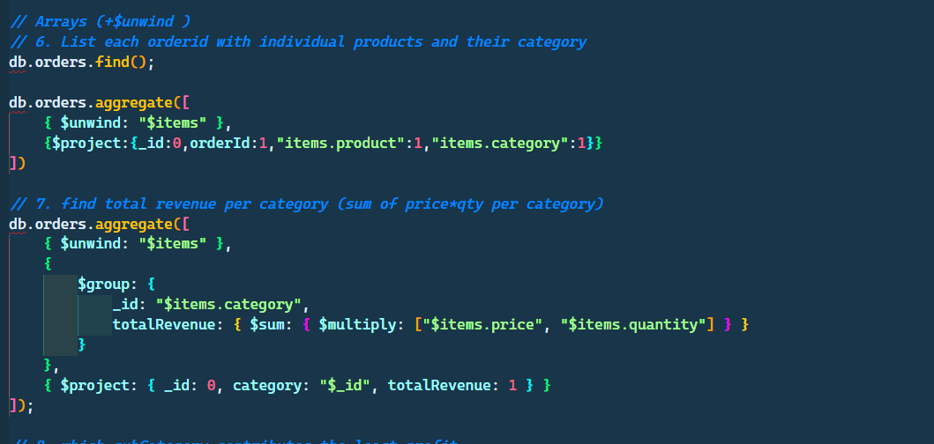
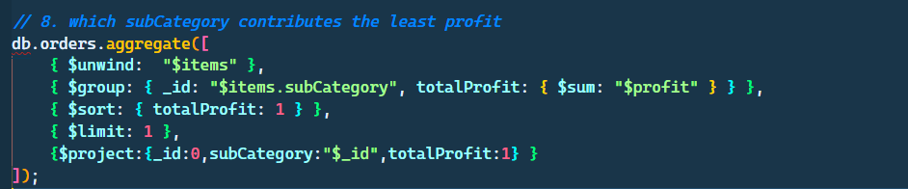
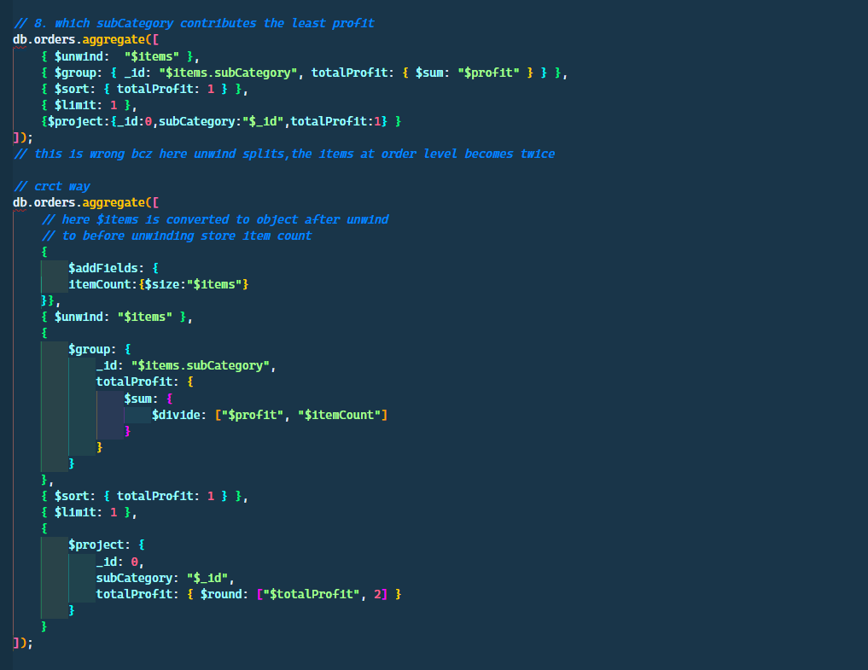
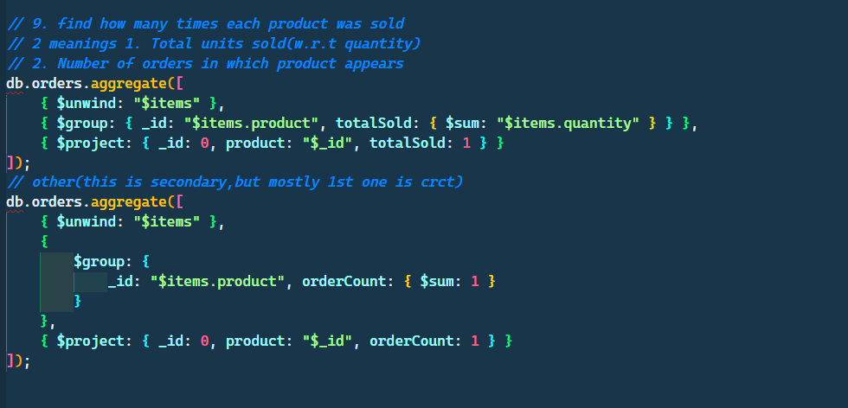

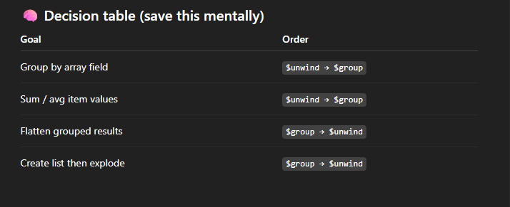
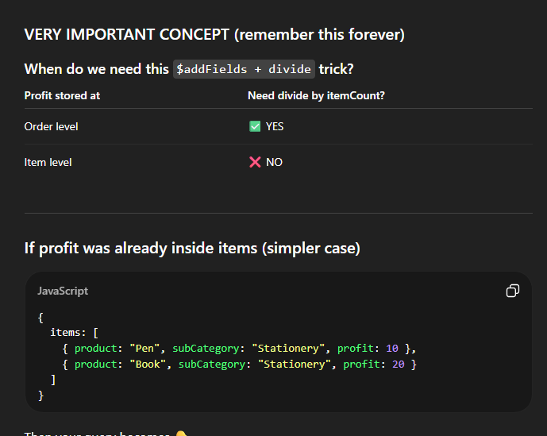
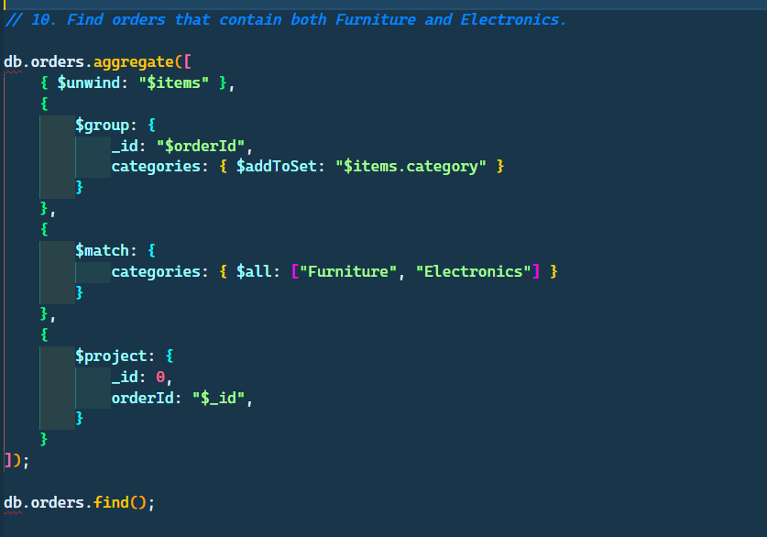
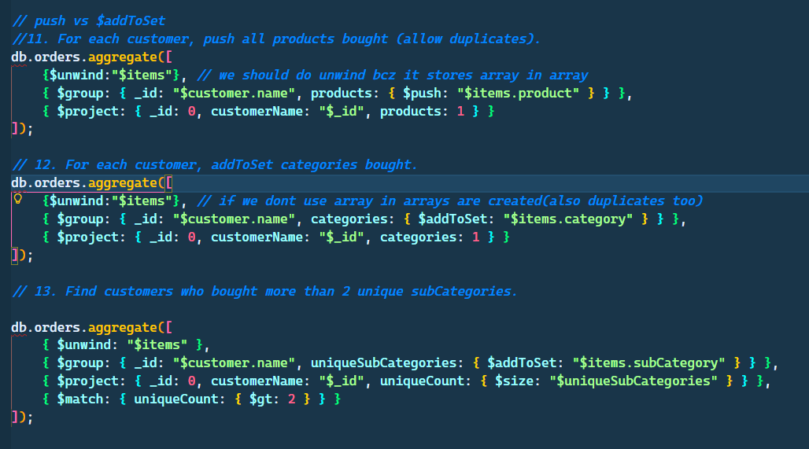
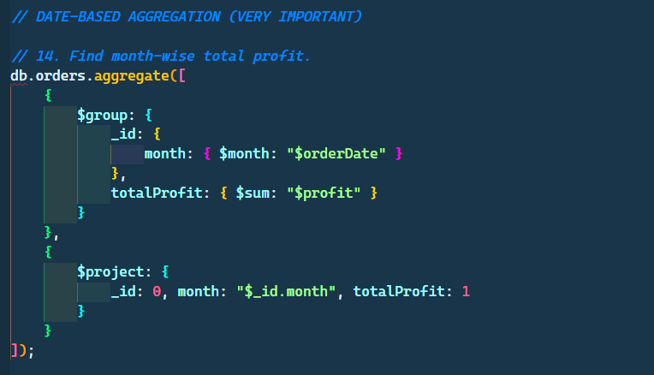
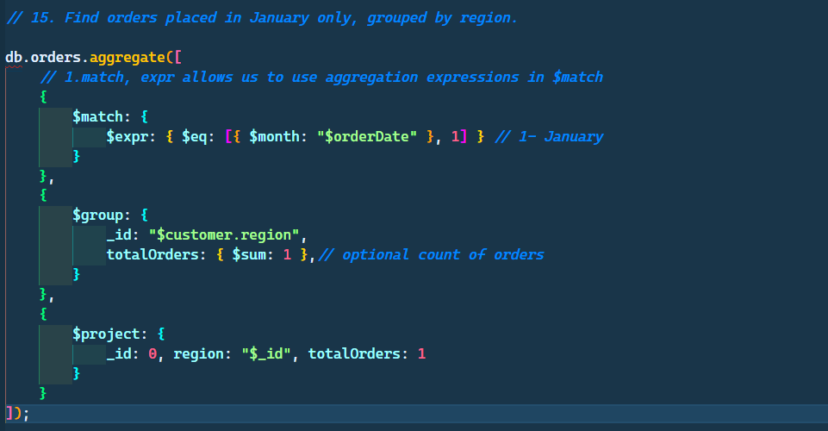

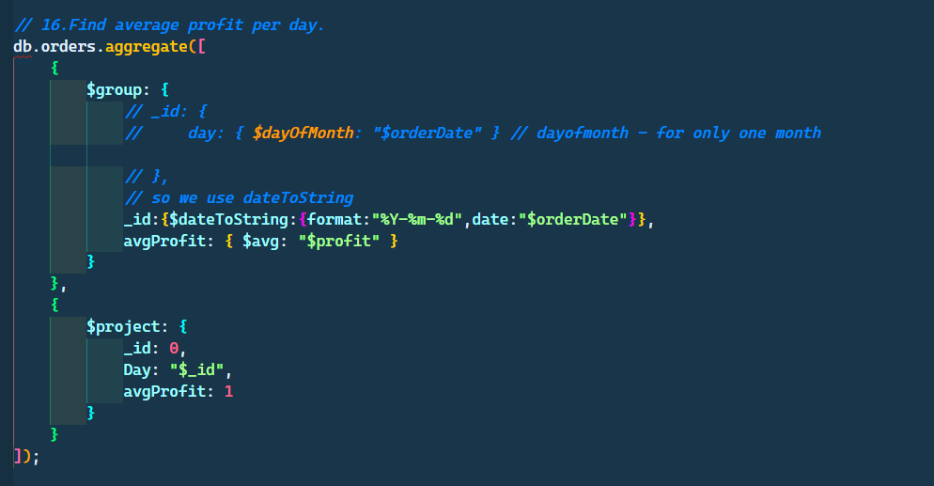
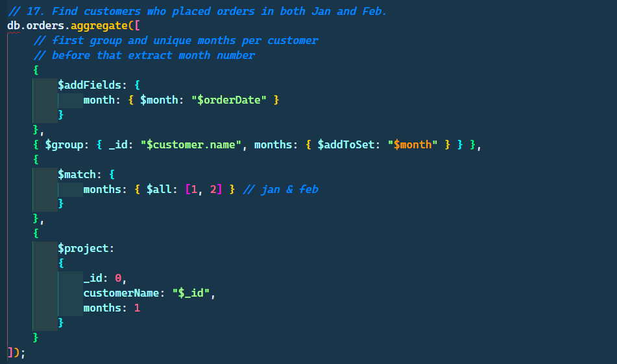
💡 Rule of thumb:
To check multiple values in the same group → $addToSet + $match: { $all: [...] }
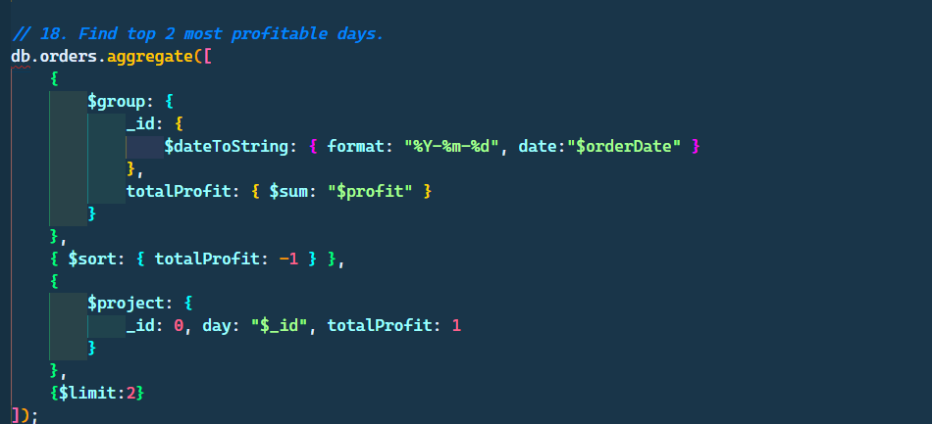
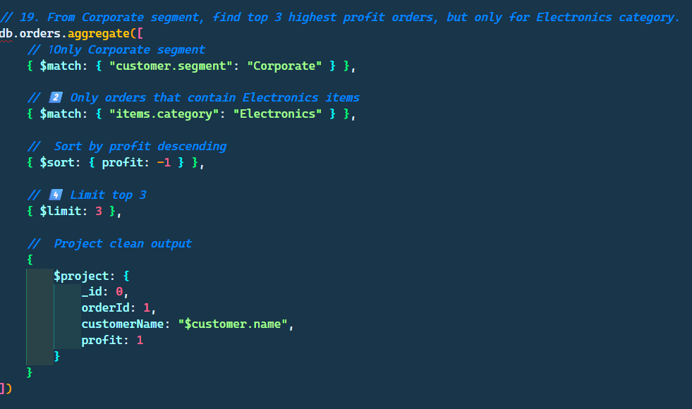
Multiple Group by
